Nov 29

Updated potential energy term in derive_everyting, behavior much better.

Arm is lighter than before – m5 = 25g; counterweight: m3 = 534-453.6g

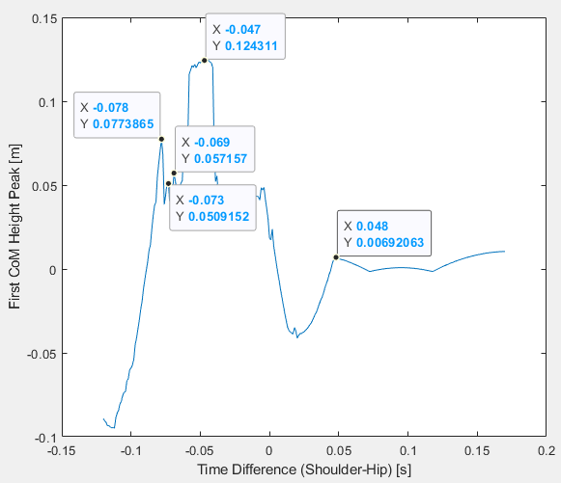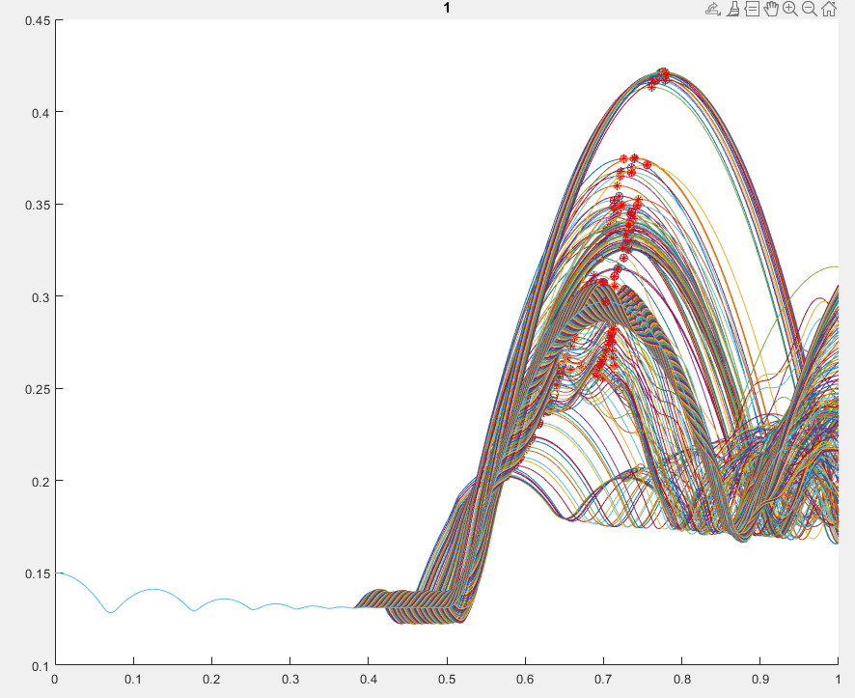

Nov 28  
8k

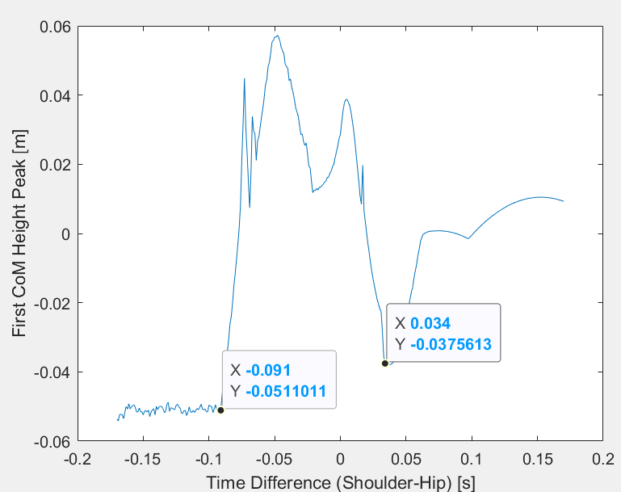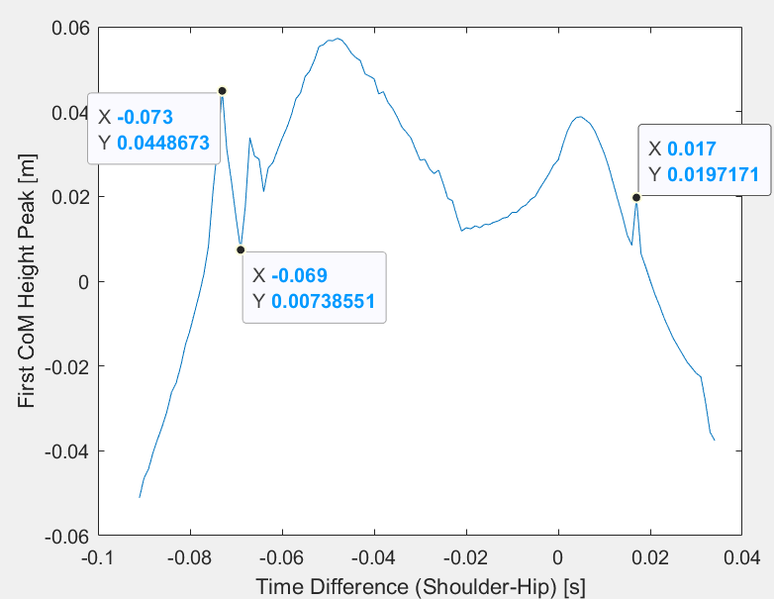

4k

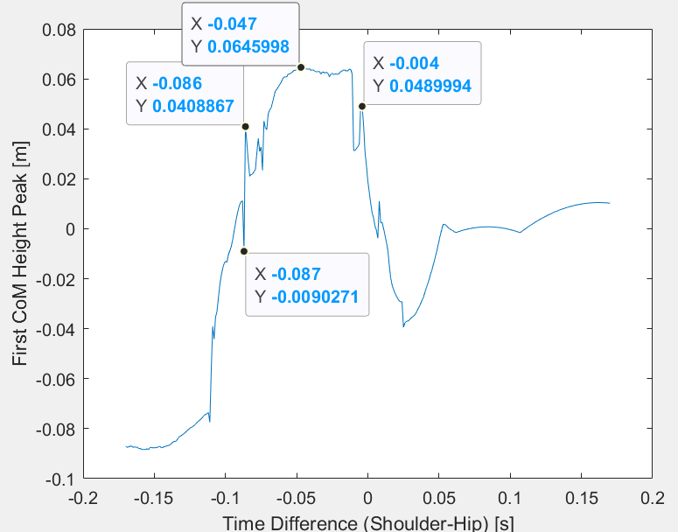

y-height for different time shifts, looking at the -0.087 vs. -0.086 especially (also did 0.0864 and 0.0865). Note divergence happens right around take-off point from a very small difference at the little hop point, suggesting some aspect of chaos/high-frequency resonance affects the system.

